MONETARY POLICY RATE : EDA Insights Report

Team members - Sanghamitra Basu, Omnia Ahmed, Somtochukwu Achi-Kanu, Chinelo Okafor, Joseph Edet

DESCRIPTION:

COLUMNS :

• Month and Year : Mon_YY : dtype – datetime object, set as index

•Variable : Value : dtype – float

•MA_30 : 30 – Day moving average

•EWMA : Exponential weighted moving average

•Log_Value : logarithm of Value columns entries

OVERALL STATS OF VALUES:

count 414.000000

mean 14.088164

std 3.903235

min 6.000000

25% 12.000000

50% 13.500000 7

5% 16.000000

max 26.250000

OVERALL TREND:

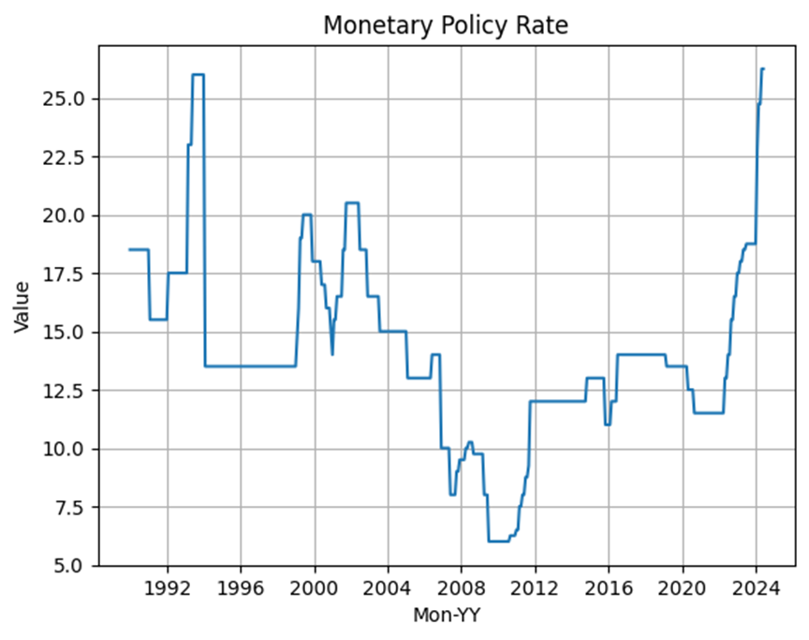

Basic inference from the trend:

•The maxima of value 26.25 is reached on 2024-05.

•The minima of value 6.00 was reached on 2009-07.

•Another local maxima can be seen in the graph around 1994.

•The most recent trend is showing a sharp increase in current years.

•The fluctuations are not very continuous, showing pretty sharp rise and fall and an overall periodicity is apparent.

DECOMPOSING THE COMPONENTS:

•2 models are used : additive and multiplicative

•Decomposed into overall trend , seasonality and residual.

•Residual plots of the 2 models compared with multiplicative model showing more randomness in residual therefore is most suitable to describe the situation.

•Also the seasonal fluctuations were not constant.

•The seasonal component showed a clear periodic fluctuation every year, with an increase in the middle of the year and dip at the end and start. The range is between 1.01 to 0.98 fraction of change.

•Also between 1994 to 2000 is a period of constant value, the longest such period.

•The plots are given in next slide.

Decomposition plots : multiplicative model: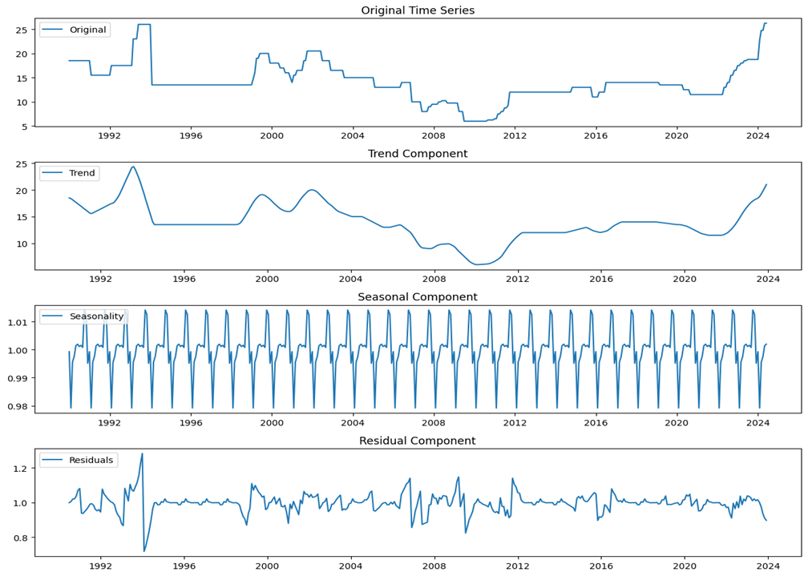

Decomposition Plots : additive model:

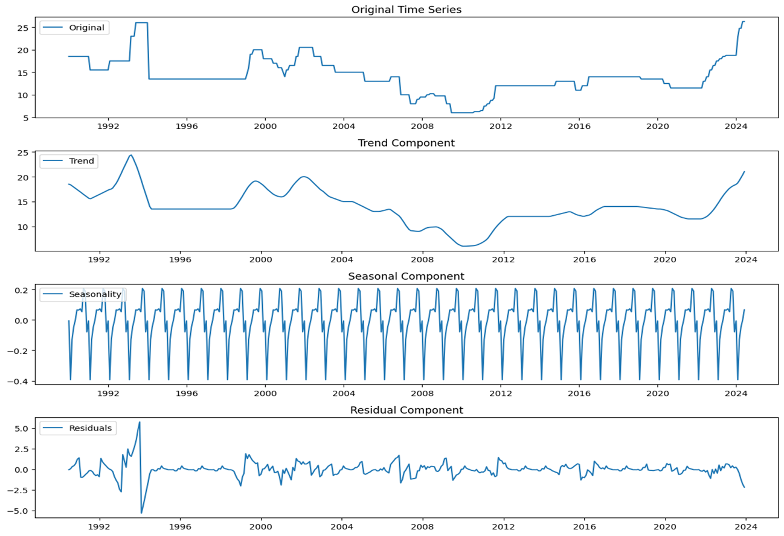

Decomposition Plot : Residual comparison:

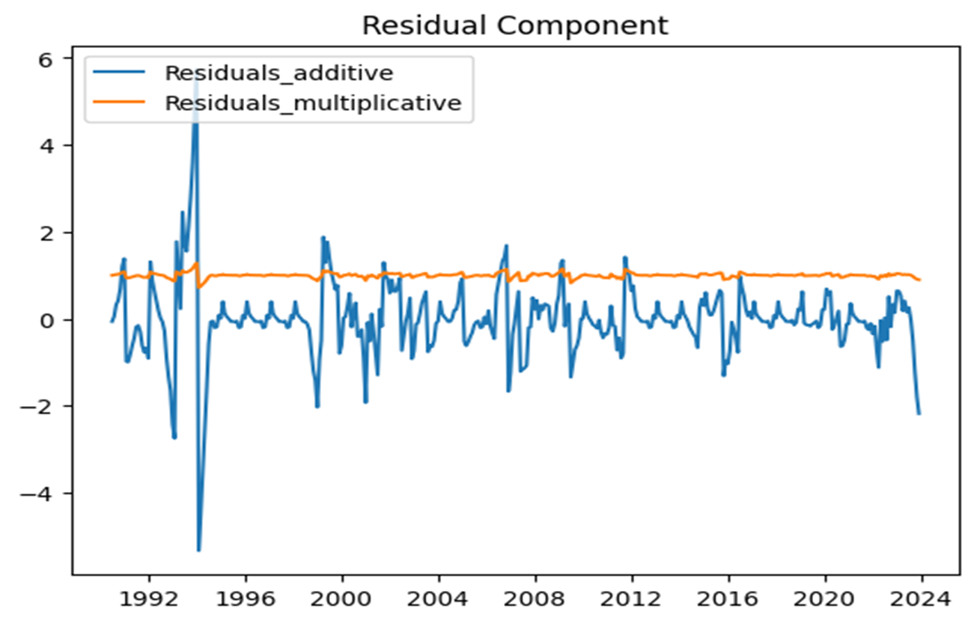

:

Log transformed values plot : Showed same trends as original data plot.:

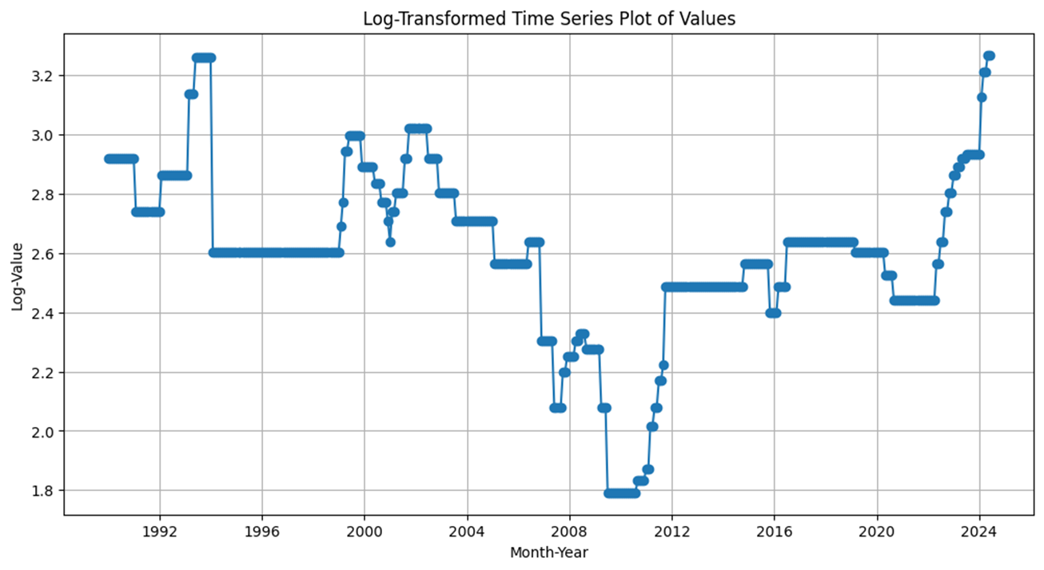

Distribution of the Values:

•The next plots (histogram and density) will show the rough distribution of the values.

•Very high and very low values have least frequencies while the median lies at 13.5, slightly less than the mean (14.0).

Histogram Plot of values:

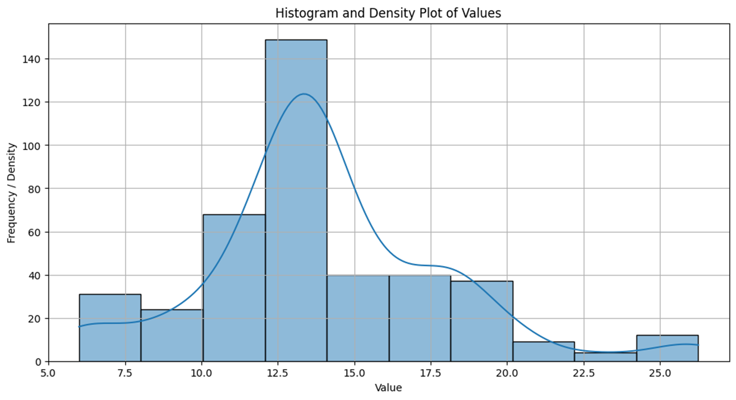

Smoothing the values to reduce noise:

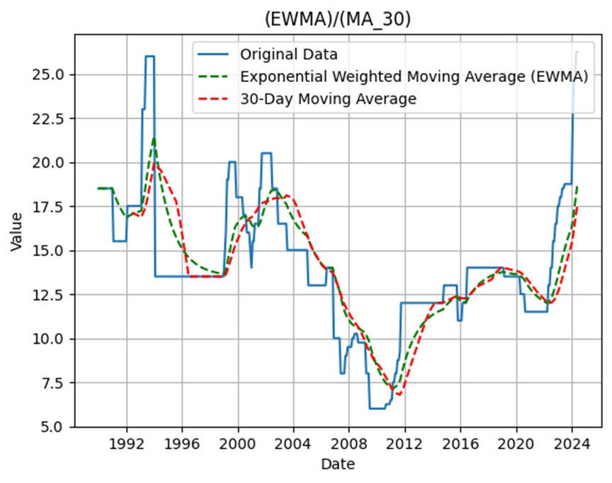

•Exponential weighted moving average method did better in capturing long term trends as is visually evident from the fit with the original data plot.

ADF Test for stationarity:

•Results :

•ADF Statistic: -1.491676117461446

•p-value: 0.5376249523400751

•Critical Values:

•1%: -3.4468044036406247

•5%: -2.868792838125

•10%: -2.57063355625

KPSS Test for Stationarity:

•KPSS Statistic: 0.8033206920143413

•p-value: 0.01

•Critical Values:

•10%: 0.347

•5%: 0.463

•2.5%: 0.574

•1%: 0.739

Conclusion:

•The stationarity test P values indicate highly non-stationary data.

•For Time-Series forcasting stationarity is needed for model performance hence the data needs to be transformed. There are various methods for the same.

•Attempt to find Correlation between Year and Values have been made but the result was : NaN. Might be some error on my side but need to look into it.